

Memorandum

To: MARUG

From: Veronica Rodgers, Natalie Carrozza, Renee Davis, Denise Burgan, Christy Allen, Jennifer Moraczewski, Penny Camacho, Russ Munroe, Vicky Brant

Date: June 17, 2022

RE: Mid-Atlantic Regional User Group Conference

Happy Friday! I can’t believe it’s already been a week since many of us were together. I want to say a HUGE Thank you to everyone who was in attendance and a special Thank you to our Board. We had a wonderful conference and I’m excited to keep the momentum going. During the next few weeks, we will be sharing a Survey Monkey which will be designed to help us plan the monthly meetings, update our contact list, and help set the pace for next years conference. The conference dates are to be determined. However, we are booking the conference again at the Homewood Suites by Hilton, Center Valley, Pa.

During the conference last week, we were very fortunate to have a lot of Jack Henry representation and several vendors. I hope everyone had the opportunity to network with other FI’s, vendors and took time to talk with Jack Henry. Since the conference many have asked for the slides for the breakout sessions. Below is a link to the Idea Lab were all the slides have been saved. Please reach out to Christy or me if you have any problems getting connected to the Idea Lab.

<https://idealab.jackhenry.com/c/idea/25780>

Again, thank you all for your time and attendance last week. If you were unable to make the Mid-Atlantic Conference, we hope to see you soon in sunny San Diego, CA. @ JH Connect. Please mark your calendars for the MARUG Meeting, August 29, 2022, from 10:15-11:15. We look forward to seeing you!!

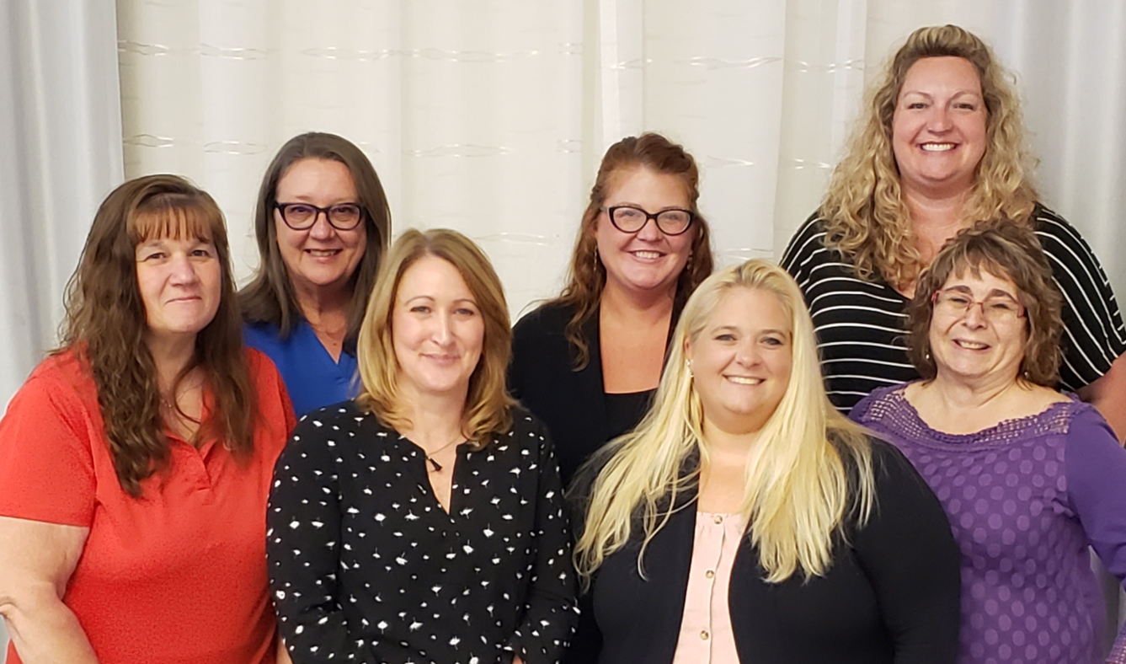

Sincerely,

Veronica Rodgers, MARUG President

Centric Bank