Key Outgoing Wire – from Customer Account Inquiry

This is the default but can be changed

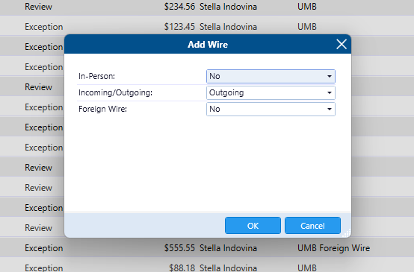

Instructing Agent = JH Bank

Instructed Agent = Receiving Bank

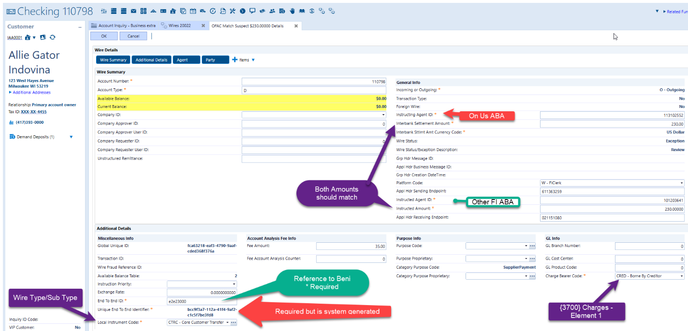

Agents are the Banks Involved

Party = Customers sending and receiving the wire

Party 1 = Creditor (Beni of the Wire )

Party 2 = Debtor (Originator of the Wire)

